**3 pc Islamic art Frame Calligraphy set**

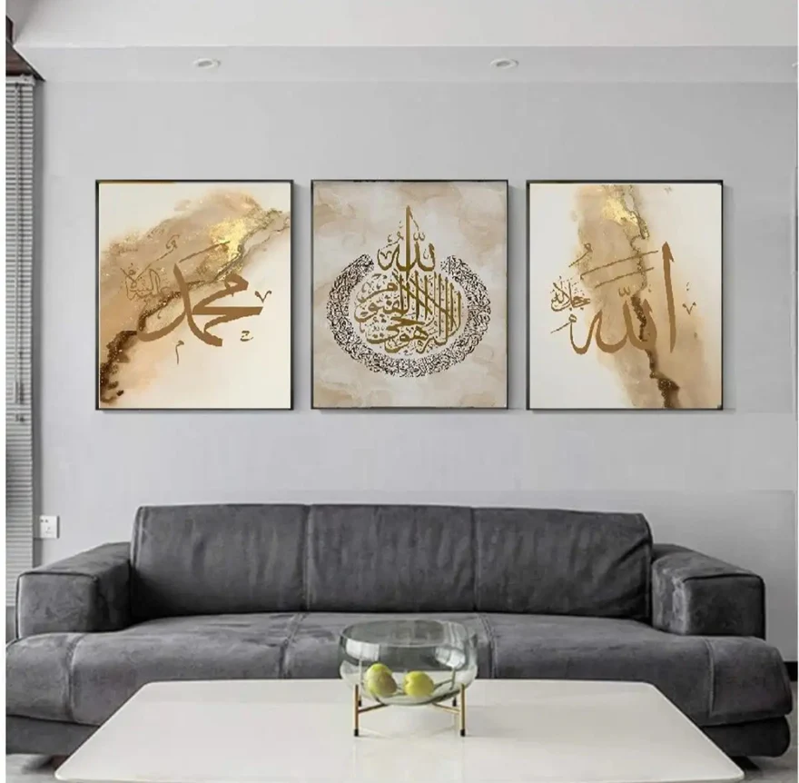The 3 PC Islamic Art Frame Calligraphy Set is a beautiful and spiritual collection designed to elevate any space with the elegance of Islamic calligraphy. Each frame features meticulously crafted Arabic script, often highlighting meaningful verses from the Quran or profound sayings of the Prophet Muhammad (PBUH). These frames are typically adorned with intricate geometric patterns or ornamental borders, blending artistry with faith. Made from high-quality materials such as wood or metal, the frames add a sense of serenity and sophistication to living rooms, prayer rooms, or offices. The set offers a harmonious way to display sacred art, allowing for a balanced, cohesive look when hung together or placed separately. This set is perfect for those looking to infuse their home with both spiritual beauty and cultural richness, creating an atmosphere of peace and reverence.